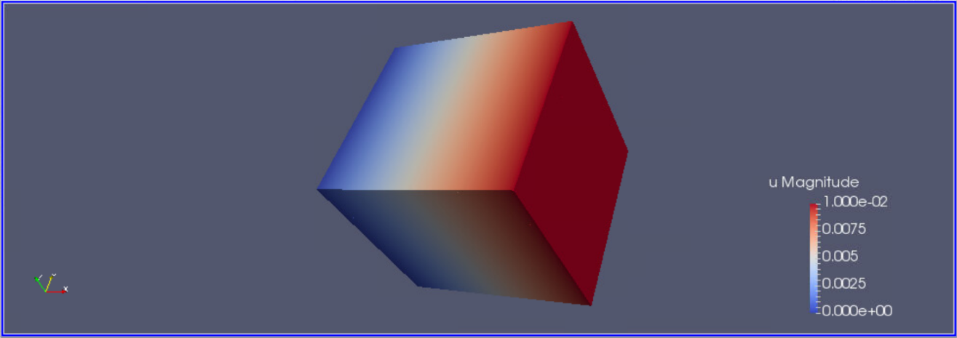

Figure : At Time = 0

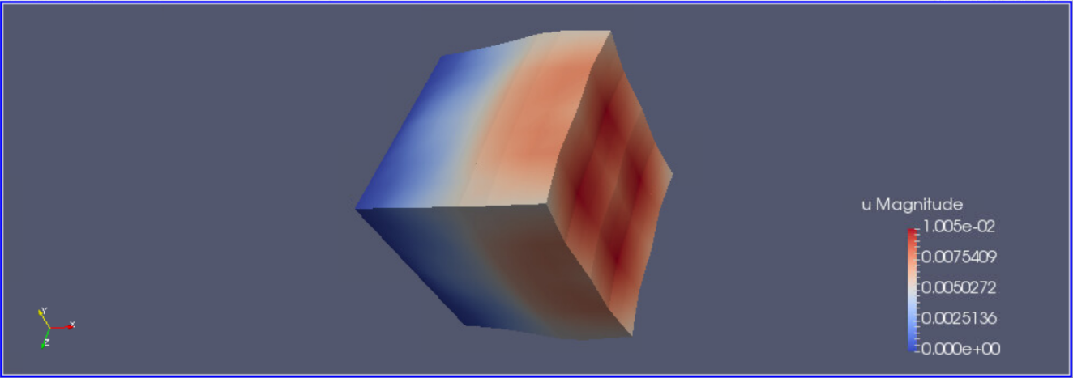

Figure : At time = 350

Figure : At time = 700

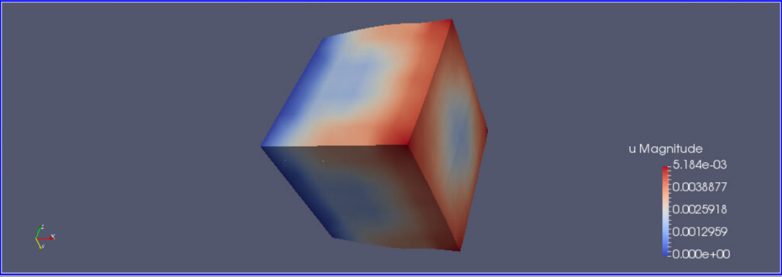

Figure : At time = 1000